**WEB DEVELOPMENT**

**PRACTICAL 3,4**

**Name:** Vrishav Garg

**Roll No.:** 12111051

**Branch:** CSE

**PRACTICAL 3:**

**CODE:**

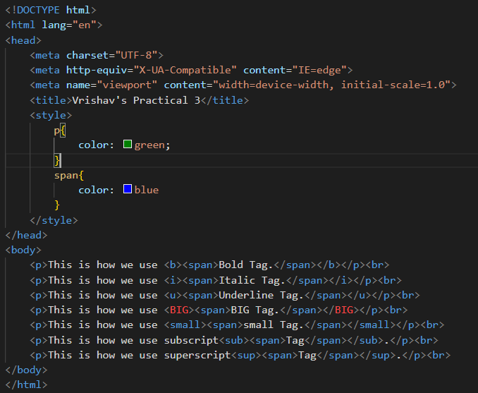

**Output:**

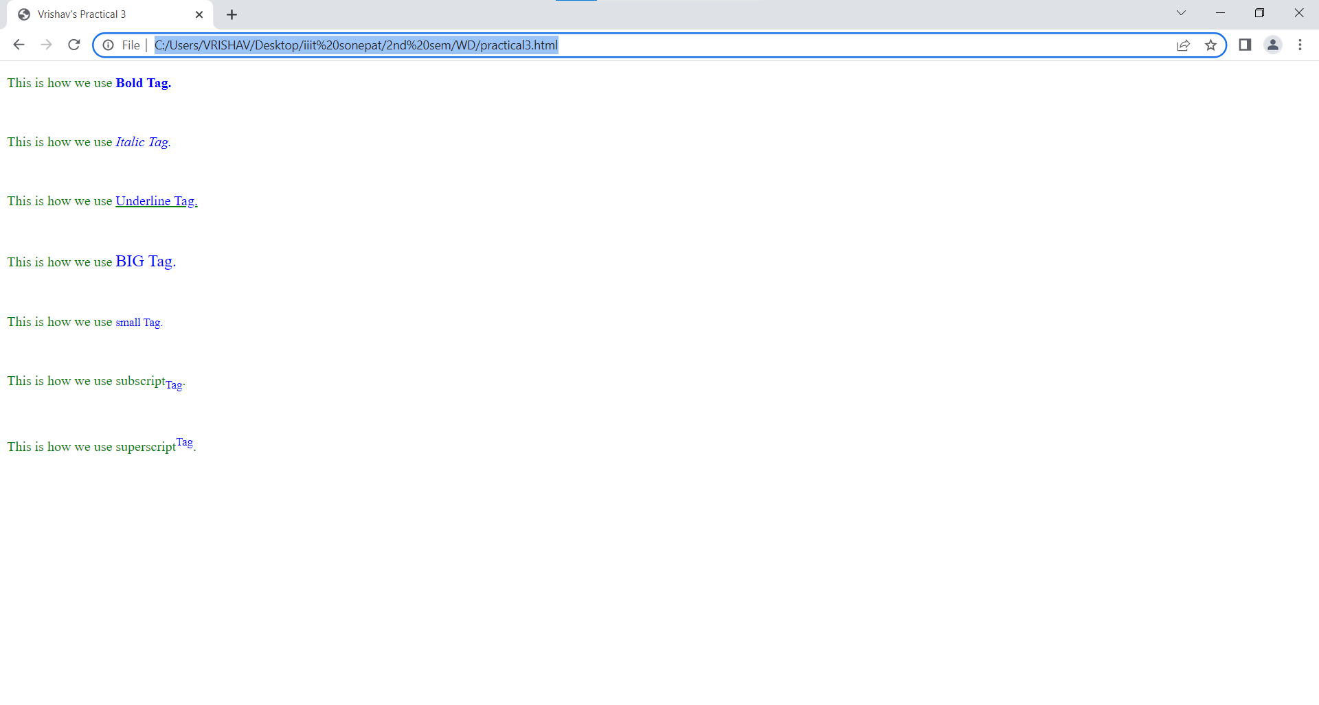

**PRACTICAL 4:**

**CODE:**

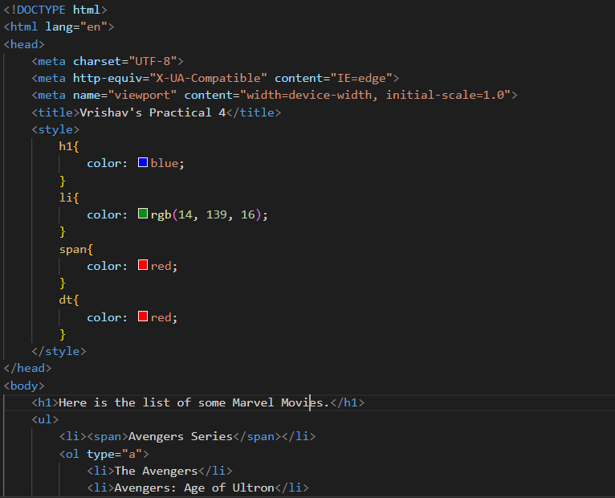

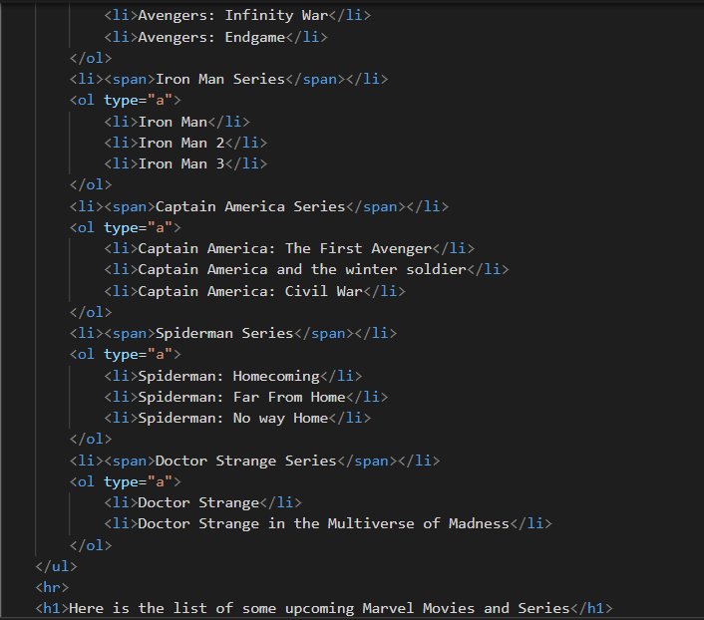

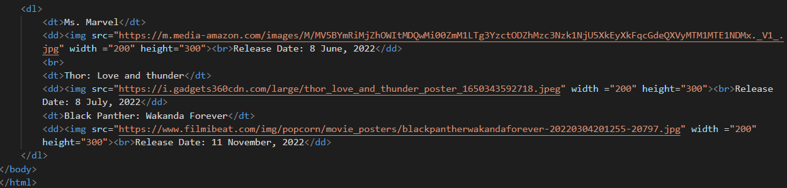

**OUTPUT:**

